**SOFTWARE ENGINEERING  
PROJECT:**

***IMAGE PROCESSING (GENDER RECOGNITION AND AGE PREDICTION)***

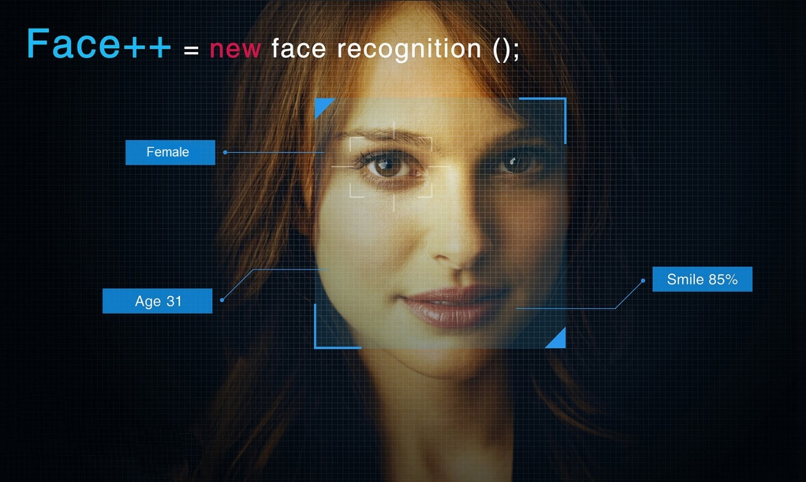

**SOFTWARE DOCUMENTATION**

Course instructor**:** *Sir Ahmed Mohsin*

**MUHAMMAD SOHAIL**

**SOHAIL ASGHAR** *(TEAM LEADER)*

**MUHAMMAD ABDULLAH**

**MUHAMMAD OMER AFFAN** *(PROJECT MANAGER)*

**Contents**

01. Preface

02. SDLC model and overview

03. Development Iteration (no. 1) planning + documentation

04. Feedback + analysis + modification report

05. Development Iteration (no. 2) planning + documentation

06. Feedback + analysis + modification report

07. Development Iteration (no. 3) planning + documentation

08. Feedback + analysis + modification report

09. General Terms and Conditions

10. Glossary

**Preface**

The software aims to

**Initial Project Requirements Analysis**

The project’s SDLC is based on the following model:

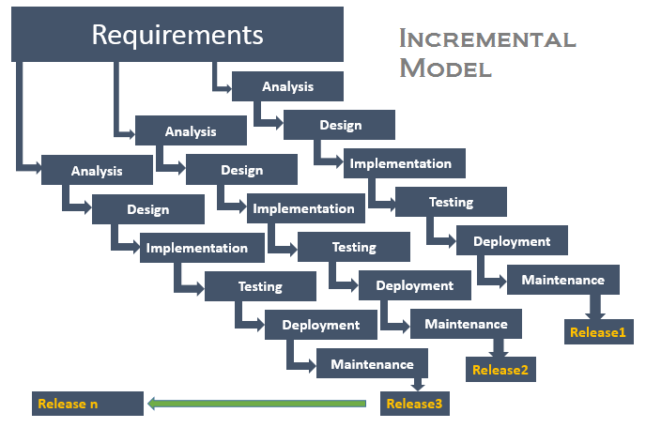

**General Terms & Conditions**

**Glossary**